Supplementary information
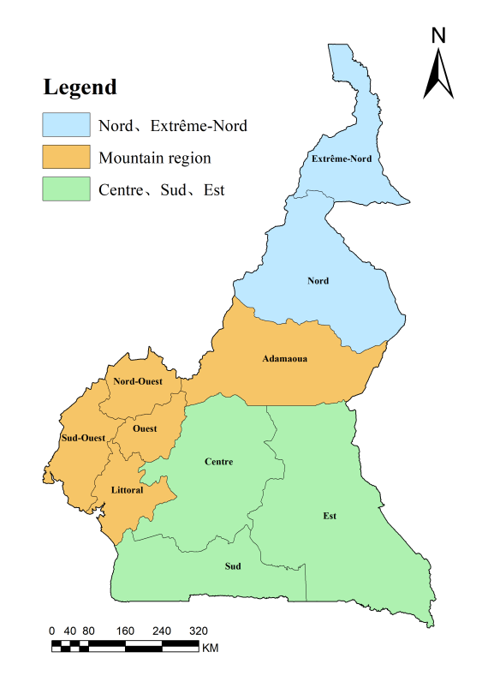
Fig. S1. Regional Study Map

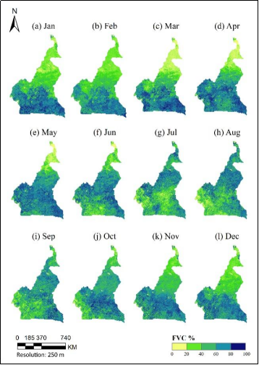
Fig. S2. Monthly Mean FVC

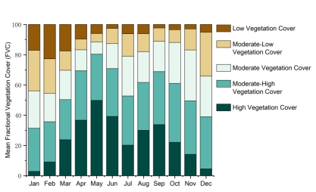
Fig. S3. Monthly FVC Stacked Chart
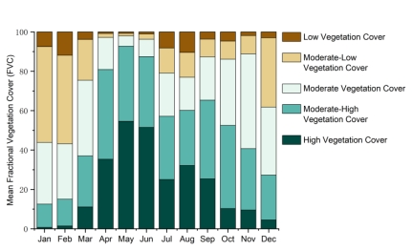
Fig. S4. Mountainous Regions FVC Stacked Chart
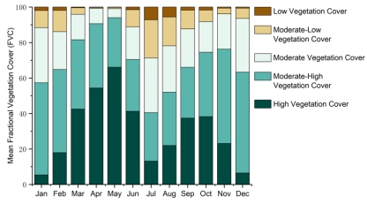
Fig. S5. Central and Southern Monthly FVC Stacked Chart
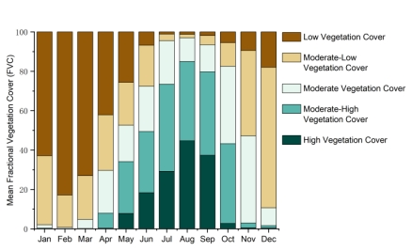
Fig. S6. Northern Monthly FVC Stacked Chart

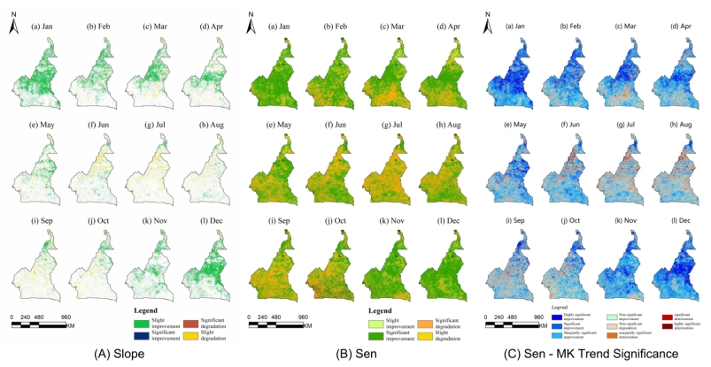
Figure S7. (a)Slope, (b) Sen and (c) Sen -MK Trend Significanc

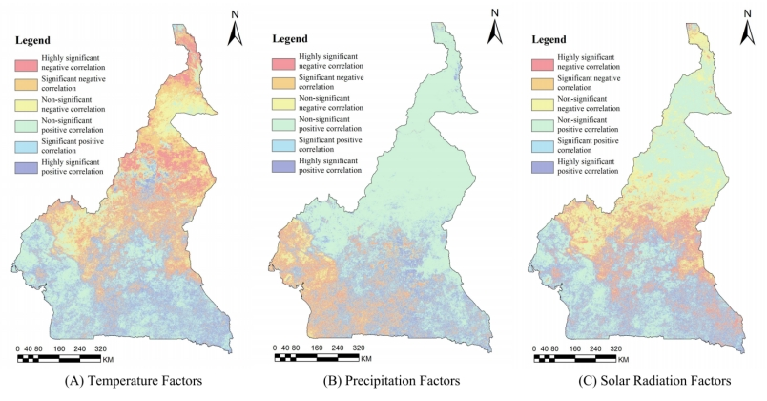
Fig.S8. (a) Temperature Factors, (b) Precipitation Factors and (c) Solar Radiation Factors

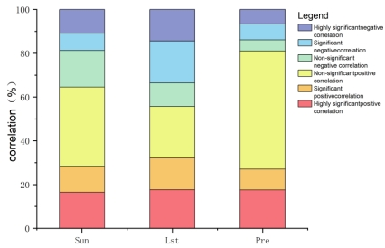
Fig. S9. FVC-Climatic Factors Correlation Stacked Chart

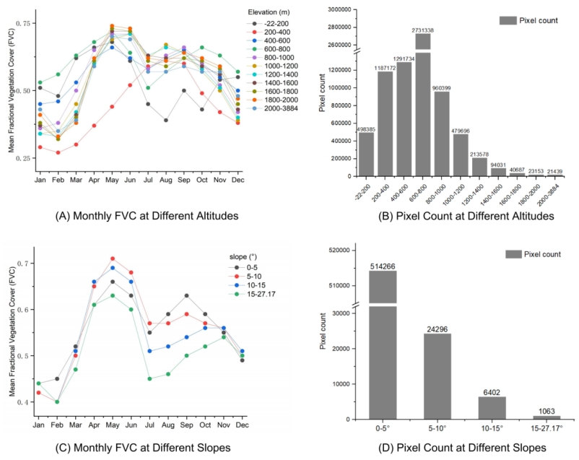
Fig. S10. (a) Monthly FVC at Different Altitudes, (b) Pixel Count at Different Altitudes, (c) Monthly FVC at Different Slopes and (d) Pixel Count at Different Slopes

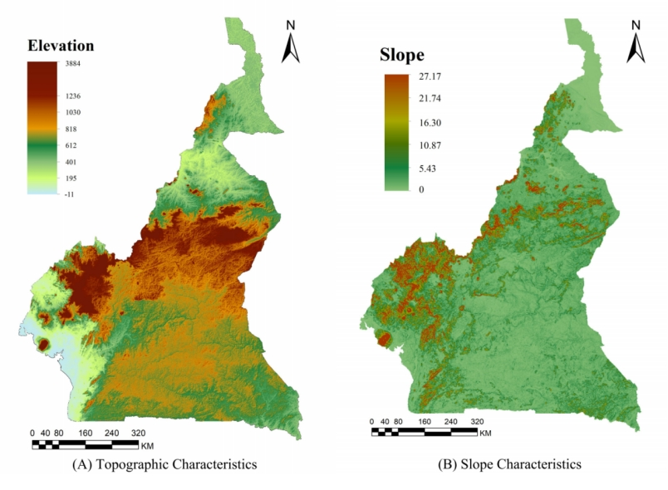
Fig. S11. (a) Topographic Characteristics and (b) Slope Characteristic

Table S1. Comparative characteristics of Cameroon’s climatic zones.
Zone | Annual Temperature (°C) | Annual Precipitation (mm) | Dominant Vegetation | Key Anthropogenic Pressures
Southern Equatorial Rainforest | 25-28 | 2000-4000 | Evergreen rainforest | Deforestation (5-10% rate), urban growth
Central Tropical Savanna | 24-30 | 1500-2000 | Savanna grasslands | Agriculture expansion (15%), grazing
Northern Sahelian Semi-Arid | 30-34 | 500-1000 | Sparse shrublands | Fuelwood collection, desertification (12% risk), population density increase

